36.74: a) Recall that the expression for the amplitude of a traveling wave is cos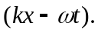 Thus each source can be thought of as a traveling wave evaluated at 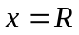with a maximum amplitude of 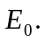 However, each successive source will pick up an extra phase from its respective pathlength to point 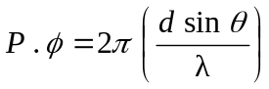 which is just 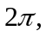 the maximum phase, scaled by whatever fraction the path difference, 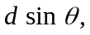is of the wavelength, 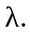By adding up the contributions from each source (including the accumulating phase difference) this gives the expression provided.
b)
The real part is just cos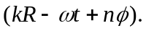
So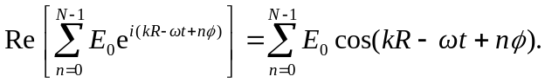
(Note: Re means “the real part of . . ..”)
but this is just
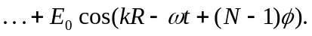
c) 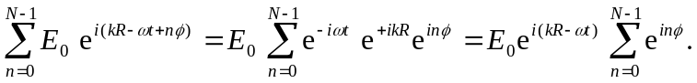
but 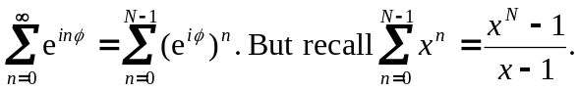
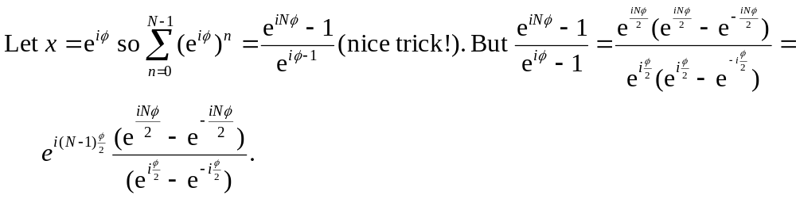
Putting everything together:
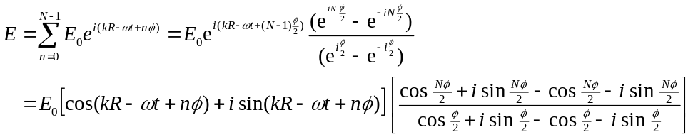
Taking only the real part gives 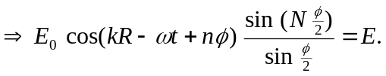
d) 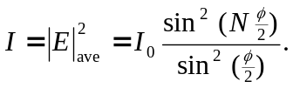 (The 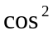 term goes to in the time average and is included in the definition of 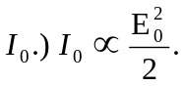
e) 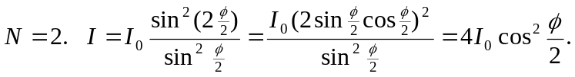 Looking at Eq. 37-10, 